TU 257 – Fundamentals of Data Science

Data Analytics

L4 – Classification – Part 2

Brendan Tierney

Agenda

•

Recap of last week

•

Lots of Algorithms

•

More this week

•

Not all possible algorithms will be covered

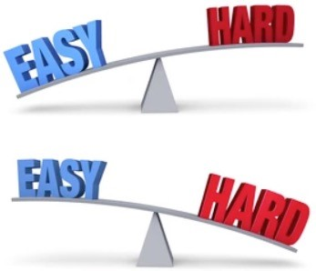

* Some details/background/under-the-hood at the algorithms
* Inner details are not needed. Can be explored in a Machine Learning module
* Recap - How do you measure if it’s any good
* Some additional ways to test and measure

# Machine Learning

• the use and development of computer systems that are able to learn and adapt without following explicit instructions, by using algorithms and statistical models to analyse and draw inferences from patterns in data.

Data Mining/Machine Learning

Classification

Regression

Clustering

Supervised MLUnSupervised ML

Association Rules Naïve Bayes

Logistic RegressionGradient BoostingDecision Trees Hierarchical ClusteringDBSCAN ClusteringKmeans FpApriori-growth

Random Forest

Support Vector Machine

K-nearest neighbors

Neural Networks

Regression AutoML

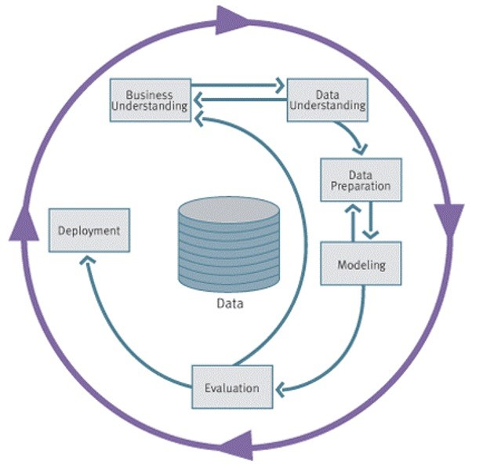

**4**

# Iteratively Building Your Knowledge

•

You are building your knowledge each week

•

This week builds upon last week

•

Next week builds upon this week

•

You build a wall block

-

by

-

block

•

This is not a programming module

–

although we are using

code to illustrate how to do it

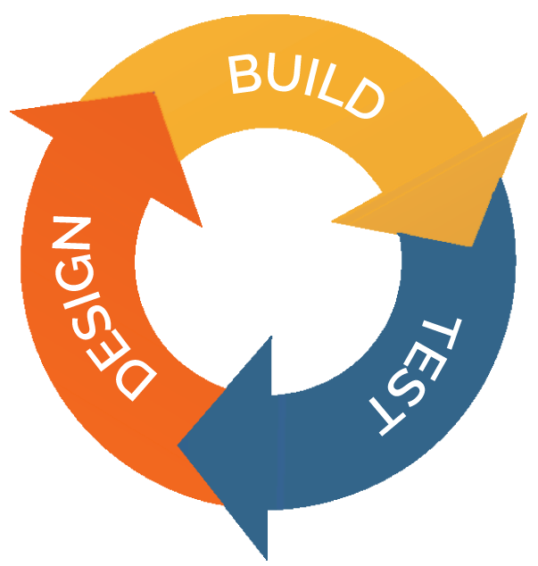

# What is Classification

* Classification is a task that requires the use of (machine learning) algorithms that learn how to assign a class label to examples from the problem domain.
* We learn from the past to predict the future
* An easy to understand example is classifying emails as “*spam*” or “*not spam*.”
* Classification predictive modeling involves
* 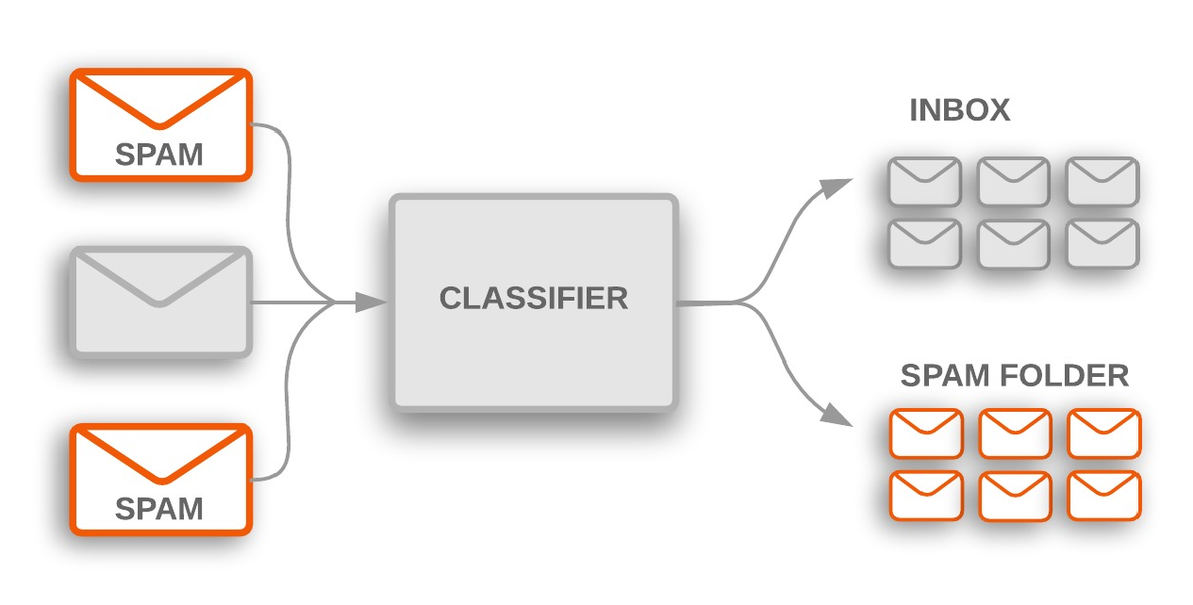Looking at historical data representing a particular scenario
* Using algorithms to find patterns in the data
* What attributes/features contribute towards determining the scenario being investigated
* Assigning a class label.

# Classification – Different types

* 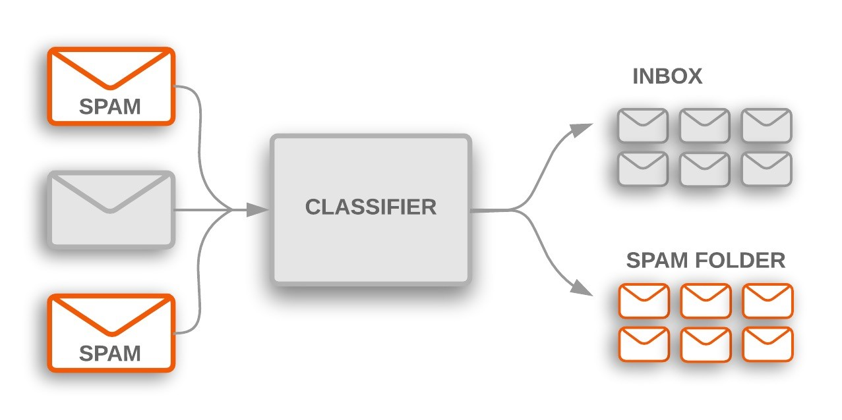Binary classification refers to predicting one of two classes
* Yes / No
* 0 / 1
* Buy / Not-Buy
* Spam / Not-Spam
* 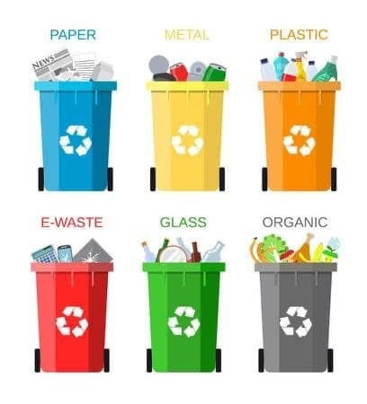Multi-class Classification is when we have more than 2 class values
* Different Fruits
* Credit Ratings
* Different Products

# Data Set = Training + Test sata sets

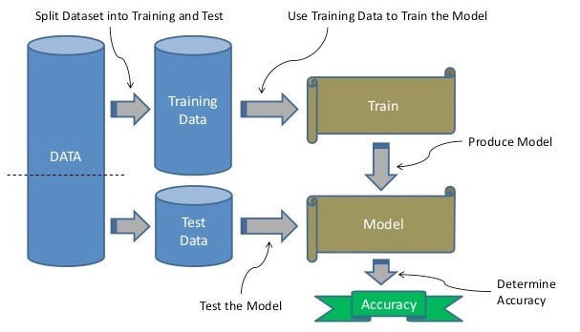

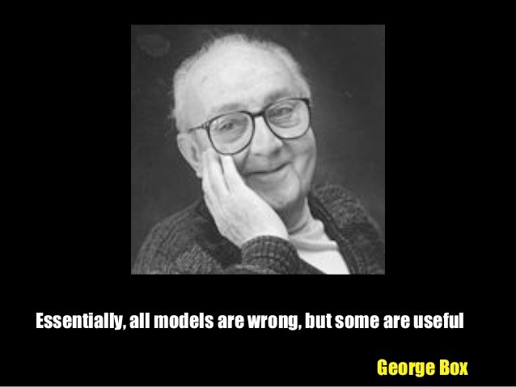

A model is a simplification or approximation of reality and hence will not reflect all of reality.

His paper was published in the Journal of the American Statistical Association, 1976 Book *Empirical Model-Building and Response Surfaces*, 1987

The Algorithms

•

Last week

•

Naive Bayes

•

Decision Trees

•

Random Forests



* XGBoost
* This week
* Knn
* Support Vector Machines
* Neural Networks (basics)

The Algorithms

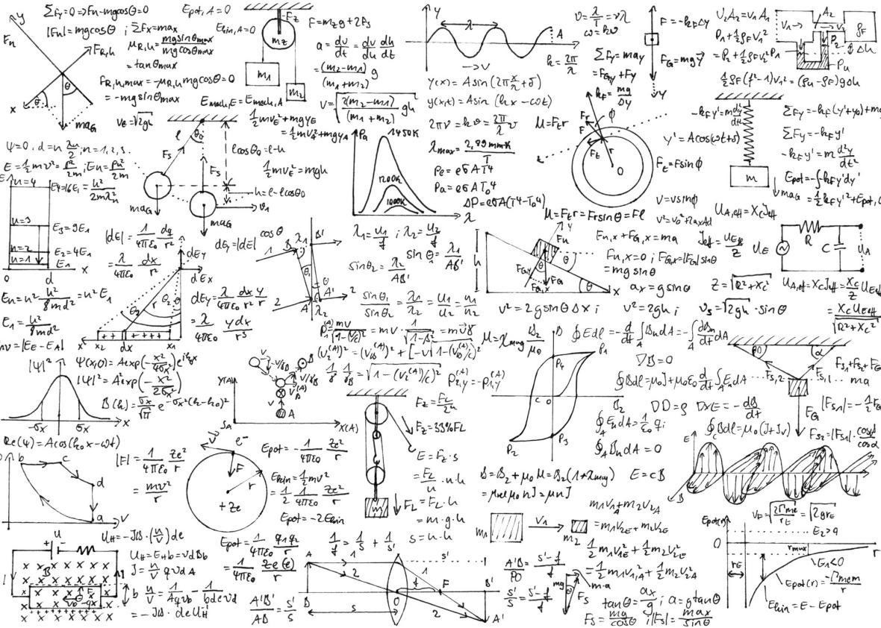

Naive Bayes

Decision Trees

Random Forests

XGBoost

KNN

SVM

Neural Networks

|  |
| --- |
| **?** |

# Nearest Neighbour Example



|  |  |  |
| --- | --- | --- |
| **Wave**  **Size**  **(ft)** | **Wave Period (secs)** | **Good**  **Surf?** |
| 6  1 5 7  6 2 3  6 4 | 15  6  11 10  11  1 4  12  2 | Yes  No  Yes Yes  Yes  No  No  Yes  No |

**Query**

10 10

# Nearest Neighbour Example

**Wave Size**

**(**

**ft**

**)**

**Wave Period**

**(**

**secs**

**)**

6

15

1

6

5

11

7

10

6

11

2

1

3

4

6

12

4

2

6

15

1

6

5

11

7

10

6

11

2

1

3

4

6

12

4

2

**Good**

**Surf?**

Yes

No

Yes

Yes

Yes

No

No

Yes

No

Yes

No

Yes

Yes

Yes

No

No

Yes

No



Get gets more difficult

as the number of

cases increase

# Knn

* Knn = K nearest neighbors
* Similarity based learning
* How similar is a record, compared to others in the data set
* Based on the idea that the observations closest to a given data point are the most "similar" observations in a data set, and we can therefore classify unforeseen points based on the values of the closest existing points. By choosing *K*, the user can select the number of nearby observations to use in the algorithm.
* Can be used in missing value imputation

# Nearest Neighbour Example

When a new case is to be classified:

***f***

***1***

***f***

***2***

**?**

**?**

**?**

**Wave Period**

**Wave Size**

* Calculate the distance from the new case to all training cases
* Put the new case in the same class as its nearest neighbour

# Nearest Neighbour Example

When a new case is to be classified:

***f***

***1***

**?**

**?**

**?**

**Wave Size**

**?**

**2**

**neighbours**

**1**

**neighbour**

**vs.**

* Calculate the distance from the new case to all training cases
* Put the new case in the same class as its nearest neighbour

What about when it’s too close to call?

Use the *k*-nearest neighbour technique

* Determine the *k* nearest neighbours to the query case
* Put the new case into the same class as the majority of its nearest

**Wave Period *f2*** neighbours

K=3

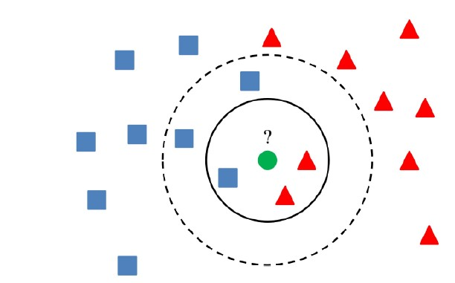

How many K value to evaluate

•

K = small => potential errors

•

K= large => lots of calculations => time

•

(

sometimes system determined

)

* K = sqrt(N)/2,
* where N stands for the number of samples in your training dataset
* IF k is an even number THEN + 1
* 5, 7 , 9, etc

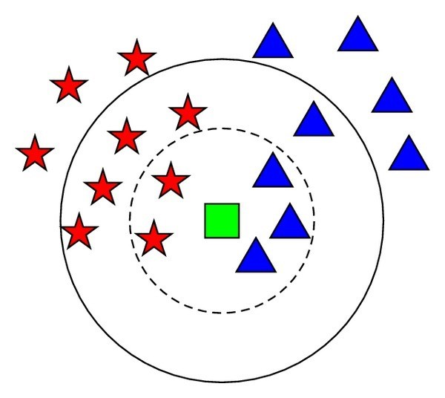Which would be better?

* To avoid any ties K=3

or

K=5

The Algorithms



KNN

SVM

Neural Networks

* A Support Vector Machine (SVM) is a supervised machine learning algorithm that can be employed for both classification and regression purposes.
* SVMs are more commonly used in classification problems.
* SVMs are based on the idea of finding a hyperplane that best divides a dataset into two classes

Support

Vectors

* Support Vectors
* Support vectors are the data points nearest to the hyperplane, the points of a data set that, if removed, would alter the position of the dividing hyperplane. Because of this, they can be considered the critical elements of a data set.

Support

Vectors

* Hyperplane
* Is a line that linearly separates and classifies a set of data.
* The further from the hyperplane our data points lie, the more confident we are that they have been correctly classified. We therefore want our data points to be as far away from the hyperplane as possible, while still being on the correct side of it.
* So when new testing data is added, whatever side of the hyperplane it lands will decide the class that we assign to it.
* Decision Boundary
* Is the gap between the data points representing the

different classes BoundaryDecision

* The bigger or wider the gap the better

Support

Vectors

* Allows for classification of data not seen in training data
* Applies internal linear functions to separate data data for each class
* Searches for function which gives the widest/biggest Decisions Boundary
* Applies internal function f(x)
* Maps data into dimensional space
* Iterates to find function f(x) with biggest Decision Boundary
* This is difficult to visualise

*f*

(

x

)

* Applies internal function f(x)
* Maps data into dimensional space
* Iterates to find function f(x) with biggest Decision Boundary
* This is difficult to visualise

*f*

)

x

(

* Labelling/Classifying new data
* Good accuracy can be achieved
* Because of f(x)
* Even if data point is in middle
* Good for Unseen data
* Longer Computation time to build model
* Understandable given f(x) and trying to create larger decision boundaries.

?

* Memory constrained
* Limitation on Size of dataset
* Up-to 250-300K records
* Very fast for labelling/Classifying new data
* It is just applying a formula f(x)

The Algorithms



KNN

SVM

Neural Networks

• Their name and structure are inspired by the human brain, mimicking the way that biological neurons signal to one another.

Neural Networks

•

Neural networks, also known as artificial neural networks (ANNs), are a

subset of

machine learning

and are at the heart of

deep

learning

algorithms.



* Suitable for a large number of problem areas
* 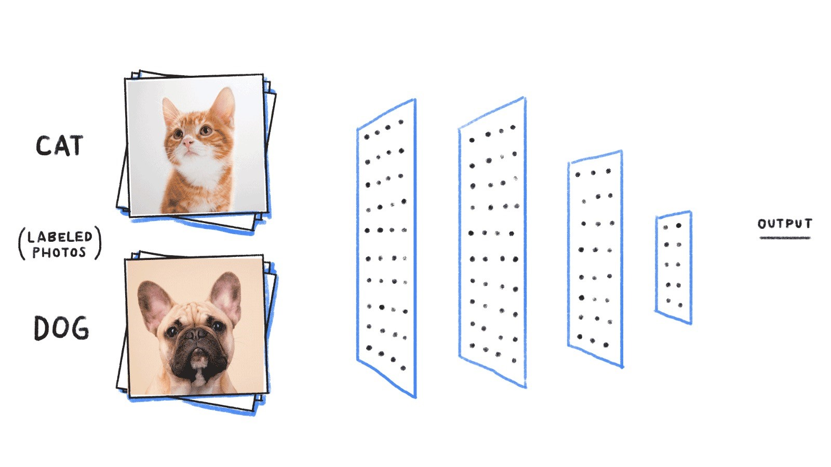Typically associated with Deep Learning
* Image processing
* Large Language Models (LMM)
* But
* Can be applied to traditional data sets
* Very slow at building models. Too much complexity
* Difficulty real time ?

# Neural Networks

•

Artificial neural networks (ANNs) are

comprised of a

node layers

, containing an

input layer

,

one or more hidden layers

, and

an

output layer

.

•

Each node

, or artificial neuron, connects to

another and

has an associated weight and

threshold

.

•

If the output of any individual node is

above the specified threshold value, that

node is activated, sending data to the next

layer of the network. Otherwise, no data is

passed along to the next layer of the

network.

A

B

C

D

Outpu

Input

A

Input

B

Input

C

Input

D

Hidden

Layer(s)

All the inputs are connected each neuron in the hidden layer (red circles).

Weights are applied to each input to a neuron

A neuron takes a set of numeric values as input and maps them to a single output value.

* A neuron is a simple multi-input linear regression function, where the output is passed through an activation function.
* Two common activations functions are logistic and tanh functions. There are many others including logistic sigmoid function, arctan function, bipolar sigmoid function, etc.

A

B

C

D

Output

Input

A

Input

B

Input

C

Input

D

Hidden Layer

All the inputs are connected each neuron in the hidden layer (red circles).

Weights are applied to each input to a neuron

A neuron takes a set of numeric values as input and maps them to a single output value.

* A neuron is a simple multi-input linear regression function, where the output is passed through an activation function.
* Two common activations functions are logistic and tanh functions. There are many others including logistic sigmoid

A

B

C

D

Output

Input

A

Input

B

Input

C

Input

D

Hidden Layer

function, arctan function, bipolar sigmoid function, etc.

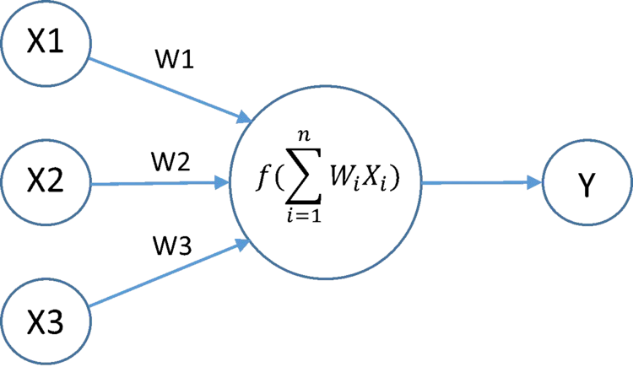

Additional hidden layers can be added

The complexity of the computations involved can increases dramatically.

But the addition of additional hidden layers gives the Neural Network to find additional and at time very complex patterns hidden in the data.

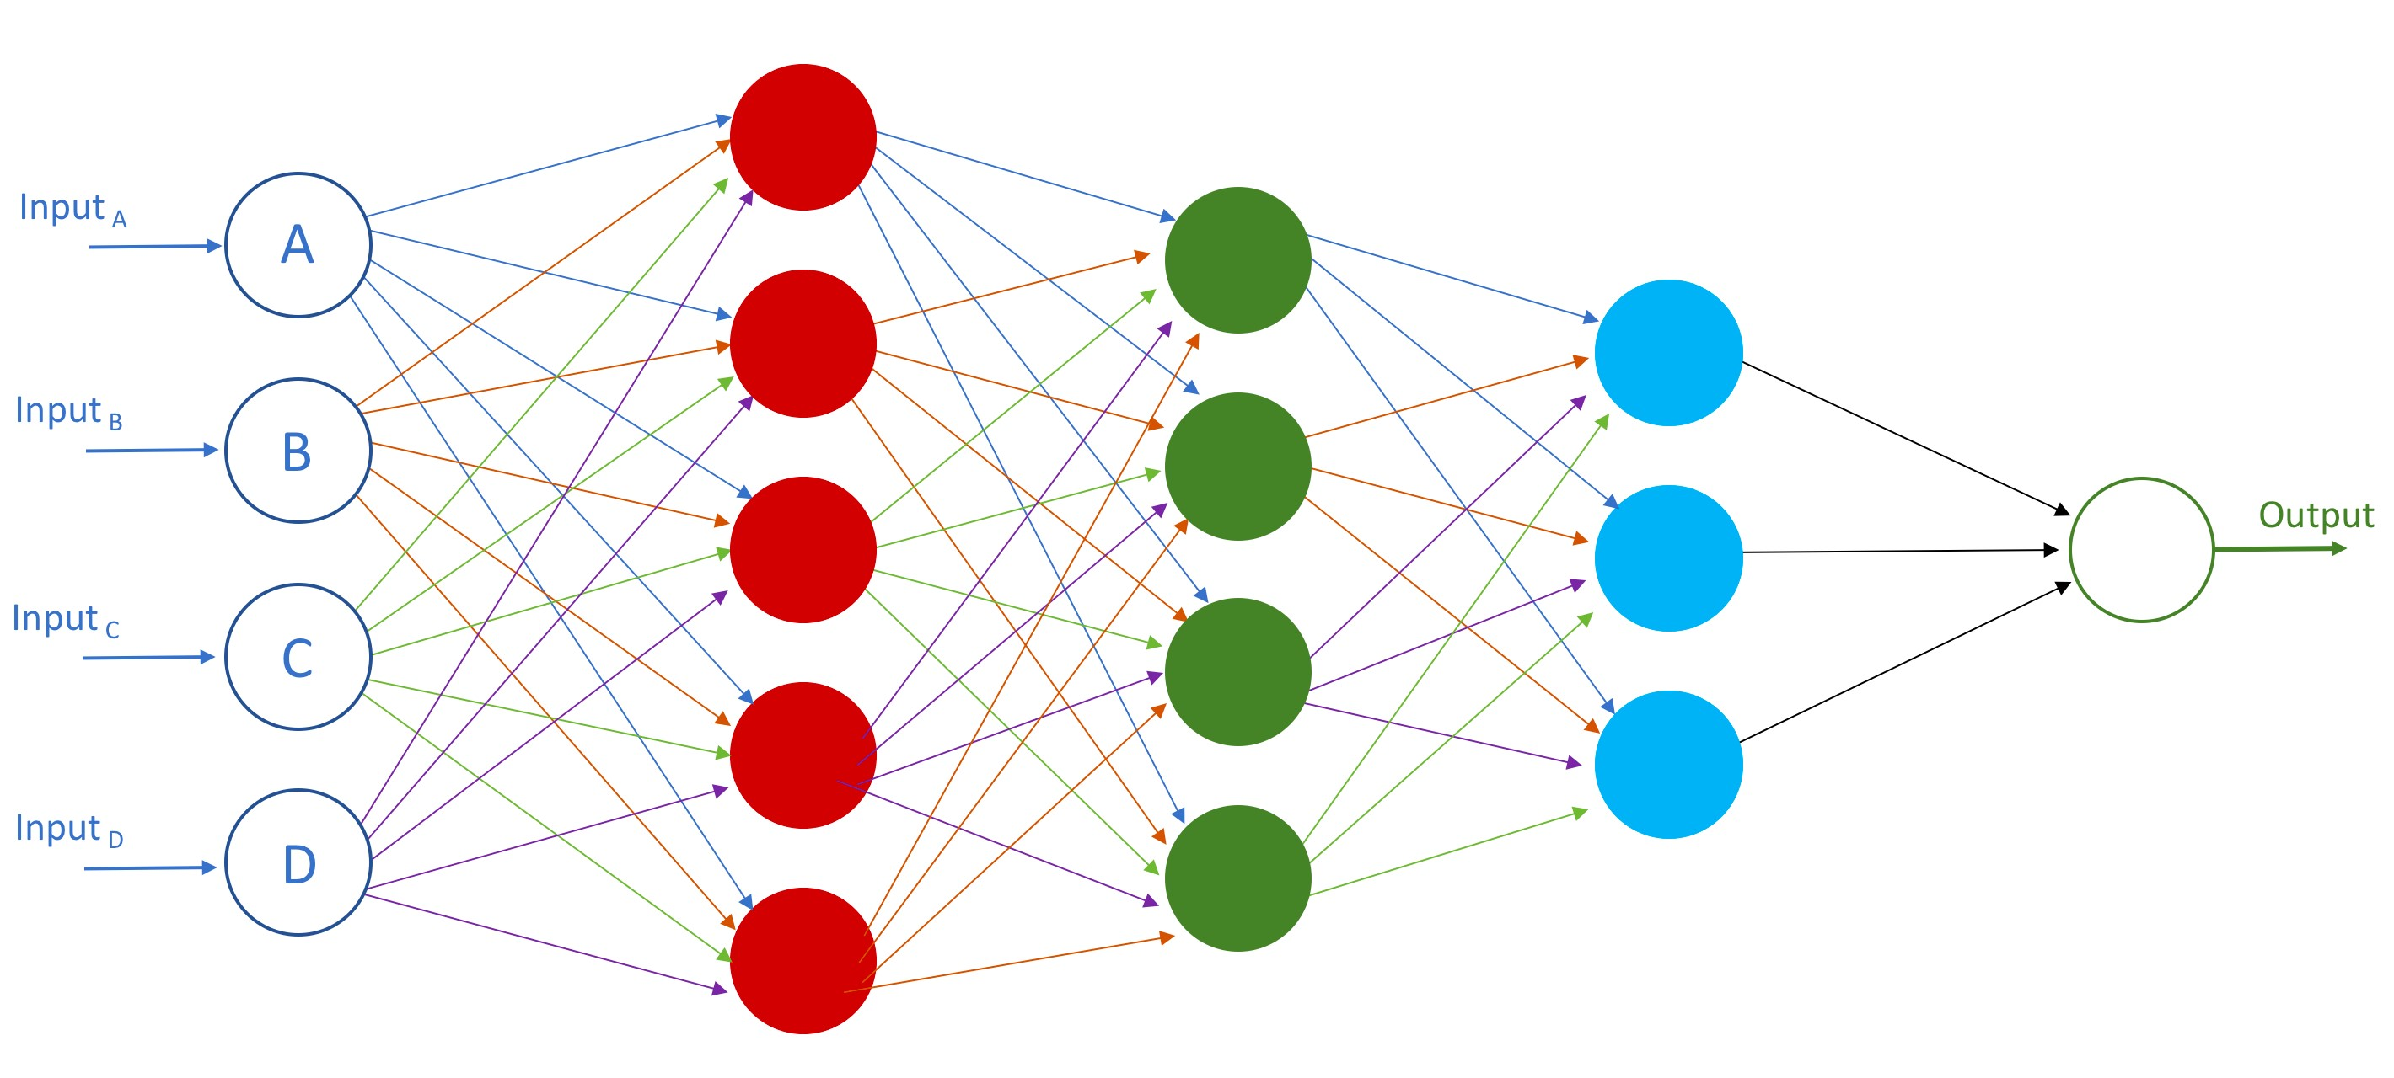

Deep Learning

* Deep Learning
* Each hidden layer finds deeper connections between the different input features
* More hidden layers => more complex processing and time

Back Propagation Neural Networks

* Training Data Set and Error rates are fed into the network (hidden layers)
* The processing at each neuron is updated and the weights rules adjusted to reduce the error rate.
* The Neural Network model starts by assuming random weights to each of the connections in the network. The algorithm then iteratively updates the weights in the network by showing training data to the network and updating the network weights until the network is optimized, in a generalized way to avoid over fitting.
* Neural Networks learn and then relearn/update themselves



Deep Learning

Errors

* Challenge 1 – Compile all the Accuracy Scores for each of the models § Which one has the best Accuracy score?
  + Can you create a bar chart to represent this data
  + We didn’t create a Naïve Bayes model for this data set
  + Go create one (using the same code) and calculate the Accuracy

# Test & Evaluate

Test & Evaluation



## Test Dataset

• We run the model against the “unseen” dataset -> Test Dataset

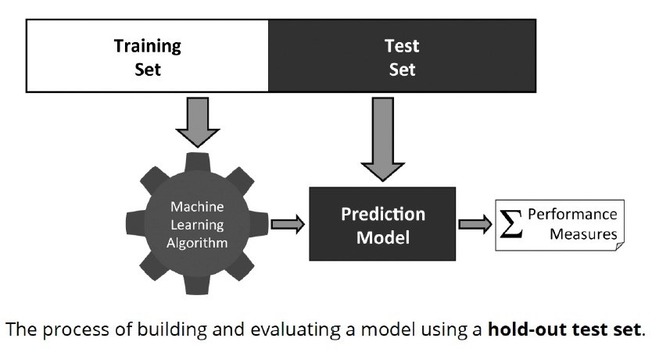

## False Positives Vs False Negatives

* While it is useful to generate the simple accuracy of a classifier, sometimes we need more
* When is the classifier wrong?
* False positives vs false negatives
* Related to type I and type II errors in statistics
* Often there is a different cost associated with false positives and false negatives § Think about diagnosing diseases

37

## Confusion Matrix

* Confusion Matrix used to illustrate how a classifier is performing in terms of false positives and false negatives
* Gives us more information than a single accuracy figure
* Allows us to think about the cost of mistakes
* Can be extended to any number of classes
* 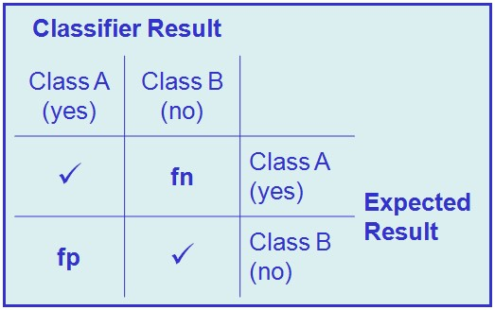Binary Classification
* Multi-Class Classification

38

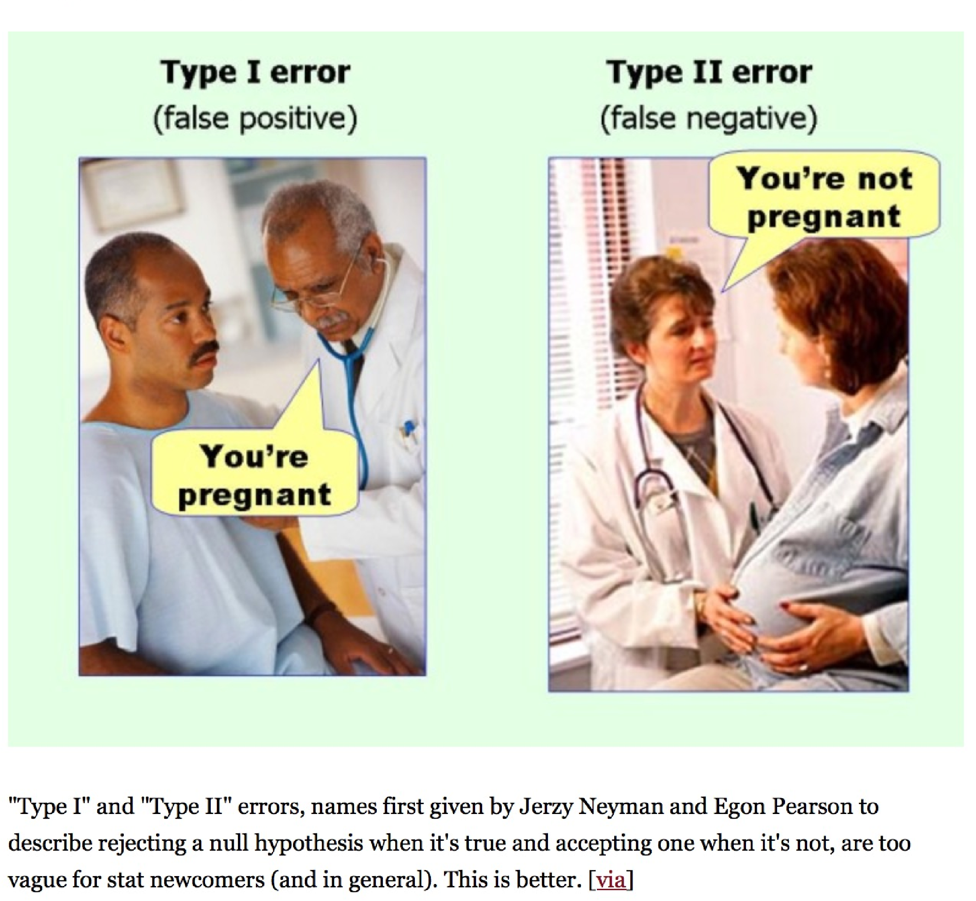Type I &

Type II

Errors

Type I &

Type II

Errors

Lots of different versions of this. All are saying the same thing

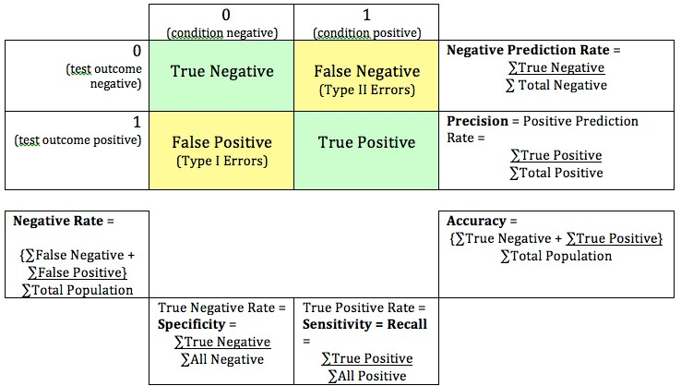



The attachment is

not

a virus

& correctly predicted

The attachment

is a

virus

& correctly predicted

The attachment is

not

a virus

but is predicted

as

a virus

The attachment

is a

virus

But I’ve predicted it as

not

being a virus

The customer commits fraud



The customer

does not

commit fraud

The customer commits fraud

The customer

does not

commit fraud

but is predicted

as

committing fraud

But is predicted as

not

committing fraud

The patient does have the condition



The patient does

not

have the condition

The patient does

have

the condition

The patient does

not

have the condition

But we have predicted

they have

condition

But we have predicted they

don’t

## Confusion Matrix

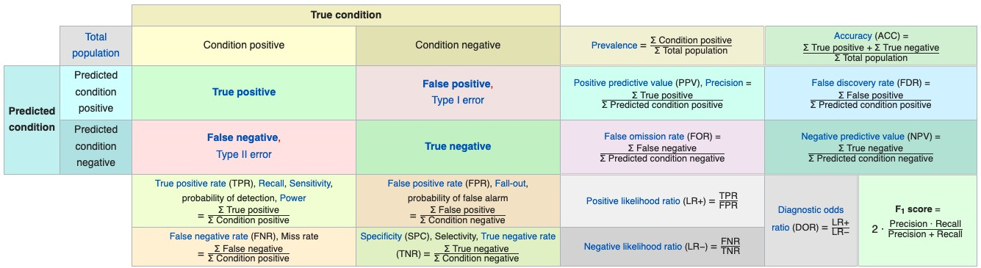

## - Example

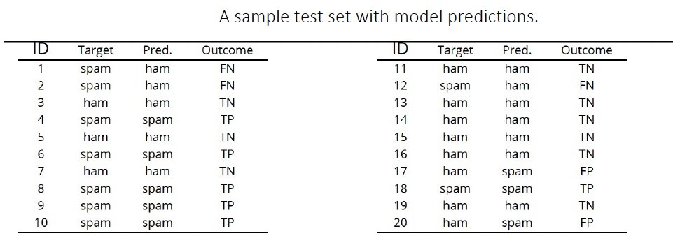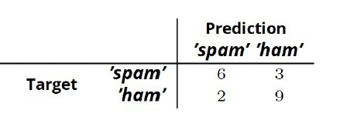

## - Example

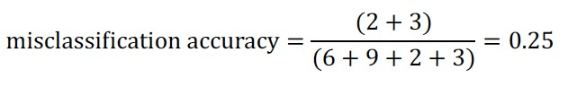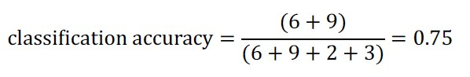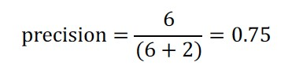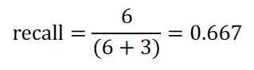

* Not every outcome (or classification) has the same value
* A positive outcome could be worth money €
* A negative outcome could be work lots of money lost -€€€
* We can apply monetary values to the outcomes

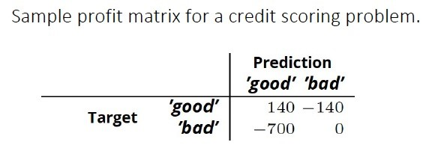

* Not every outcome (or classification) has the same value
* A positive outcome could be worth money €
* A negative outcome could be work lots of money lost -€€€
* We can apply monetary values to the outcomes



How much

€

can we make by

getting this correct

We will do nothing with these.

So no cost/

€

We should have approved these.

But we didn’t.

Missed opportunity cost

* Not every outcome (or classification) has the same value
* A positive outcome could be worth money €
* A negative outcome could be work lots of money lost -€€€
* We can apply monetary values to the outcomes



How much

€

can we make by

getting this correct

We will do nothing with these.

So no cost/

€

We should have approved these.

But we didn’t.

Missed opportunity cost

* Not every outcome (or classification) has the same value
* A positive outcome could be worth money €
* A negative outcome could be work lots of money lost -€€€
* We can apply monetary values to the outcomes



How much

€

can we make by

getting this correct

We will do nothing with these.

So no cost/

€

We should have approved these.

But we didn’t.

Missed opportunity cost

* Add up the numbers from each part/box of the Confusion Matrix
* Total = € potential value for model
* Accountants like to see these numbers
* Your managers like to see these numbers
* Bosses like to see these numbers
* It quantifies/costs the potential € for each model
* The Business will understand using € (Language of Business)
* Vs using Numbers + Percentages + Unusual Terms (Language of Analysts, Machine Learning, etc )

## ROC Curves

* *Receiver Operating Characteristic* (ROC) curves were originally used to make sense of noisy radio signals
* 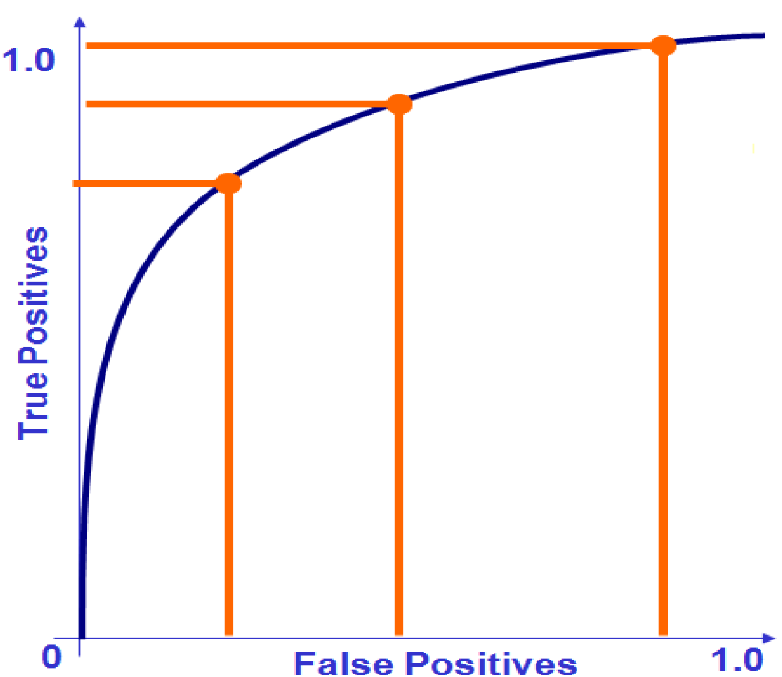Can be used to help us talk about classifier performance and determine the best operating point for a classifier
* Considers how the relationship between true positives and false positives can change
* We need to choose the best operating point

## ROC Curves (cont…)

* 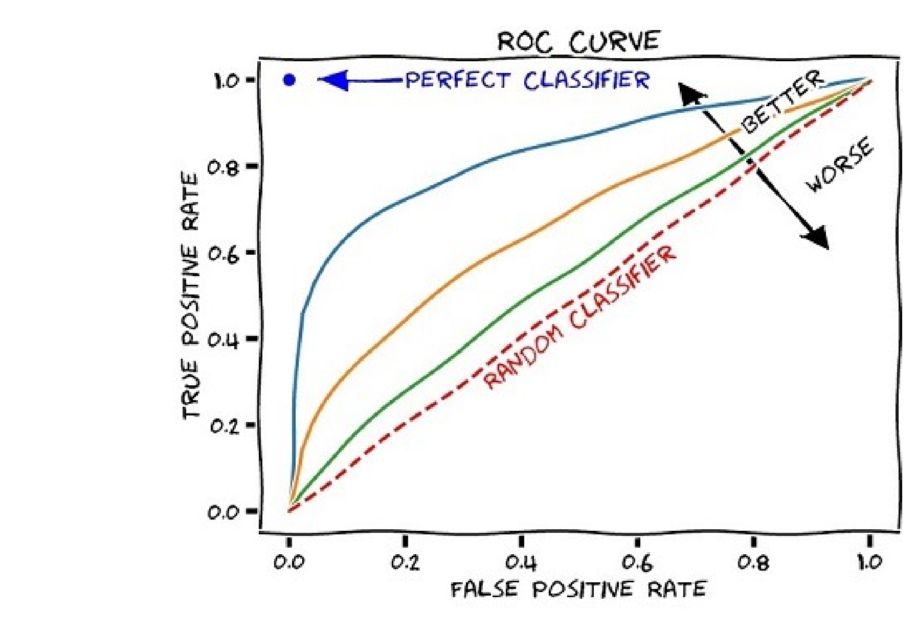ROC curves can be used to compare classifiers
* The greater the Area Under the Curve (AUC) the more accurate the classifier

AUC stands for *Area under the ROC Curve.* It provides an aggregate measure of performance across all possible classification thresholds.

The higher the area under the ROC curve (AUC), the better the classifier.

A perfect classifier would have an AUC of 1. Usually, if your model behaves well, you obtain a good classifier by selecting the value of the threshold that gives TPR close to 1 while keeping FPR near 0.

• Challenge 1 – Compile all the Accuracy Scores for each of the models § Which one has the best Accuracy score?

* Can you create a bar chart to represent this data
* We didn’t create a Naïve Bayes model for this data set
* Go create one (using the same code) and calculate the Accuracy
* Challenge 2 – Calculate the ROC and AUC for all the models § Which one has the best AUC value?

## Hold-Out Testing Sets

* Split the available data into a *training set* and a *test set*

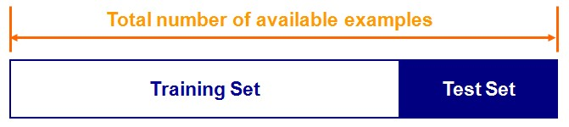

* Train the classifier in the training set and evaluate based on the test set
* A couple of drawbacks
* We may not have enough data
* We may happen upon an *unfortunate split*

## K-Fold Cross Validation

* An alternate is to divide the dataset into smaller chunks (Train & Test)
* k *folds* – where k is the number of times to divide the data
* For each of k experiments, use kth fold for testing and everything else for training
* Average the results across the k folds

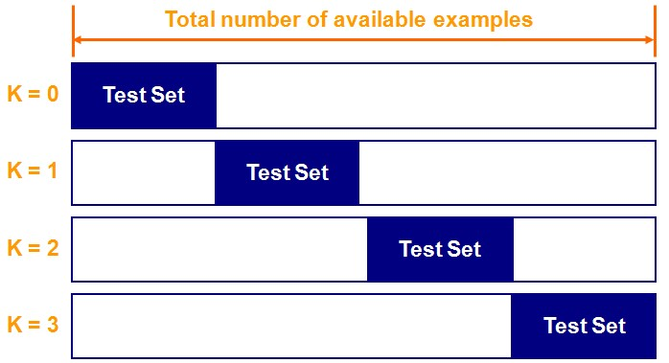

## K-Fold Cross Validation

* The accuracy of the system is calculated as the average error across the k folds
* The main advantages of k-fold cross validation are that every example is used in testing at some stage and the problem of an *unfortunate split* is avoided
* Any value can be used for k
* 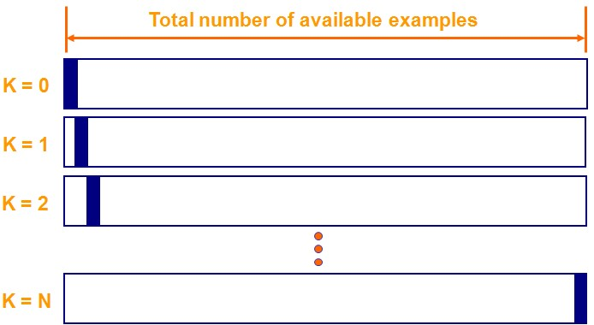10 is most common
* Depends on the data set

• Challenge 1 – Compile all the Accuracy Scores for each of the models § Which one has the best Accuracy score?

* Can you create a bar chart to represent this data
* We didn’t create a Naïve Bayes model for this data set
* Go create one (using the same code) and calculate the Accuracy
* Challenge 2 – Calculate the ROC and AUC for all the models § Which one has the best AUC value?
* Challenge 3 – Using Kfold Cross-Validation for all models § Which one has the best average Accuracy score?

Experiment



## Experience

### How long does Machine Learning take

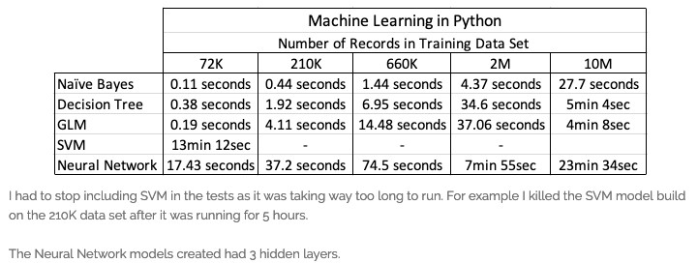

[https://oralytics.com/2019/02/05/machine-learning-models-in-python-how-long-does-it-tak](https://oralytics.com/2019/02/05/machine-learning-models-in-python-how-long-does-it-take/)e/

Model Update

* Do we need to update the models ?
* New (initial) Model
* Reflects the current position

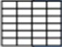

Model



New

Data

Model



Historical

Data

* We keep gathering new data/cases
* Update a Model

Concept Drift

* How often do we need to update the models ?

A lot covered

•

We have covered a lot in this class (and previous)

•

What is Classification & What it can be used for

•

Different Algorithms

•

How to Evaluate

•

Keep It Simple!

•

Lab Work

•

Examples of the Algorithms

•

Examples of Evaluation

•

It’s only a few

lines

of code!



* Assignment A – is based on topics covered up to and including this week + Next Week
* Topics after next week (Week 7) are not part of or required for Assessment-A
* Topics in Week 7 and after will be part of Assessment-B
* Topics in Week 7 – first half for Assessment-A + second half for Assessment-B

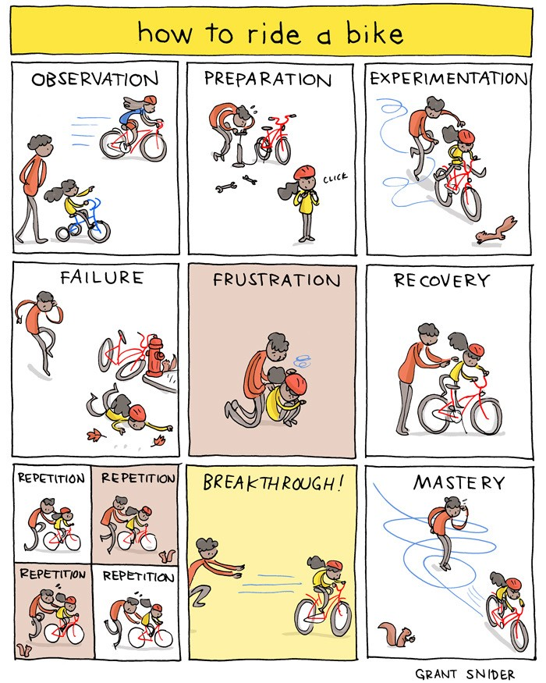

Time for an

Example

Any Questions ?

What Now/Next ?